

# Aspera R40

## Type of device: Mobile

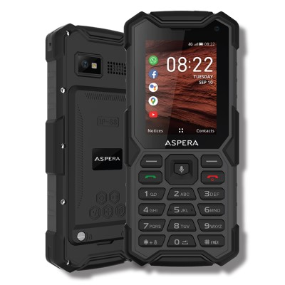

Actual Display Size : 2.4 inches

Button Type : Physical Keypad

Network Capability : 3G,4G

Year of Release : 2021

Average Price : $132 as of 11 06 2021

Other : KaiOS

## Accessibility Features:

### Cognitive

* GPS
* Screen Timeout Disabled
* Simple Instructions
* Simple Reminders
* Simplify Display

Voice Notes

### Hearing Impairment and Deaf

* Bluetooth or Wi-Fi
* Front Facing Camera
* Text Messaging/SMS

Visual Alerts - Incoming Calls

### Vision

* Bluetooth or Wi-Fi
* Brightness Adjustable
* Key Marker – Raised '5'
* Key Numbers - Standard Layout
* Key Press - Vibration or Click
* Personalised Shortcuts

Text Size Adjustable

### Speech

* Bluetooth or Wi-Fi
* Messaging Options - Email
* Messaging Options - IM
* Messaging Options - MMS

Predictive Text

### Physical

* Bluetooth or Wi-Fi
* Guarded/Recessed Keys
* Headset - plug connected
* Physical Dialling Keys
* Predictive Text
* Speaker-phone option

Switch control option

## How and where to get it from?

You can buy this phone from [Mobileciti](https://www.mobileciti.com.au/aspera-r40-4g-rugged-phone-keypad-ip68-black), [Retravision](https://www.retravision.com.au/aspera-r40-rugged-4g-black-p02241701), [Dick Smith](https://www.dicksmith.com.au/da/buy/aspera-r40-4g-rugged-phone-keypad-ip68-black-09351424000277/), [Allphones](https://www.allphones.com.au/aspera-r40-4g-rugged-phone-keypad-ip68-black), [Kogan](https://www.kogan.com/au/shop/?q=aspera+r40), and other retailers.

## More information is available on:

[Aspera R40 Webpage](https://asperamobile.com/phones/rugged-phones/aspera-r40/)

[Aspera R40 User Manual (PDF Download)](https://asperamobile.com/wp-content/uploads/2021/01/R40-User-manual-print-version.pdf)

[Aspera R40 FAQs](https://asperamobile.com/aspera-r40-faqs/)